**Hereford Residential College short course**

**A HILL AND AN ACADEMICAL VILLAGE Fall 2023**

credits: 1 hr. Wednesdays 4-5:30 pm | Sept 6 through Nov 8

Instructor: Nancy Takahashi/ Associate Professor Emeritus

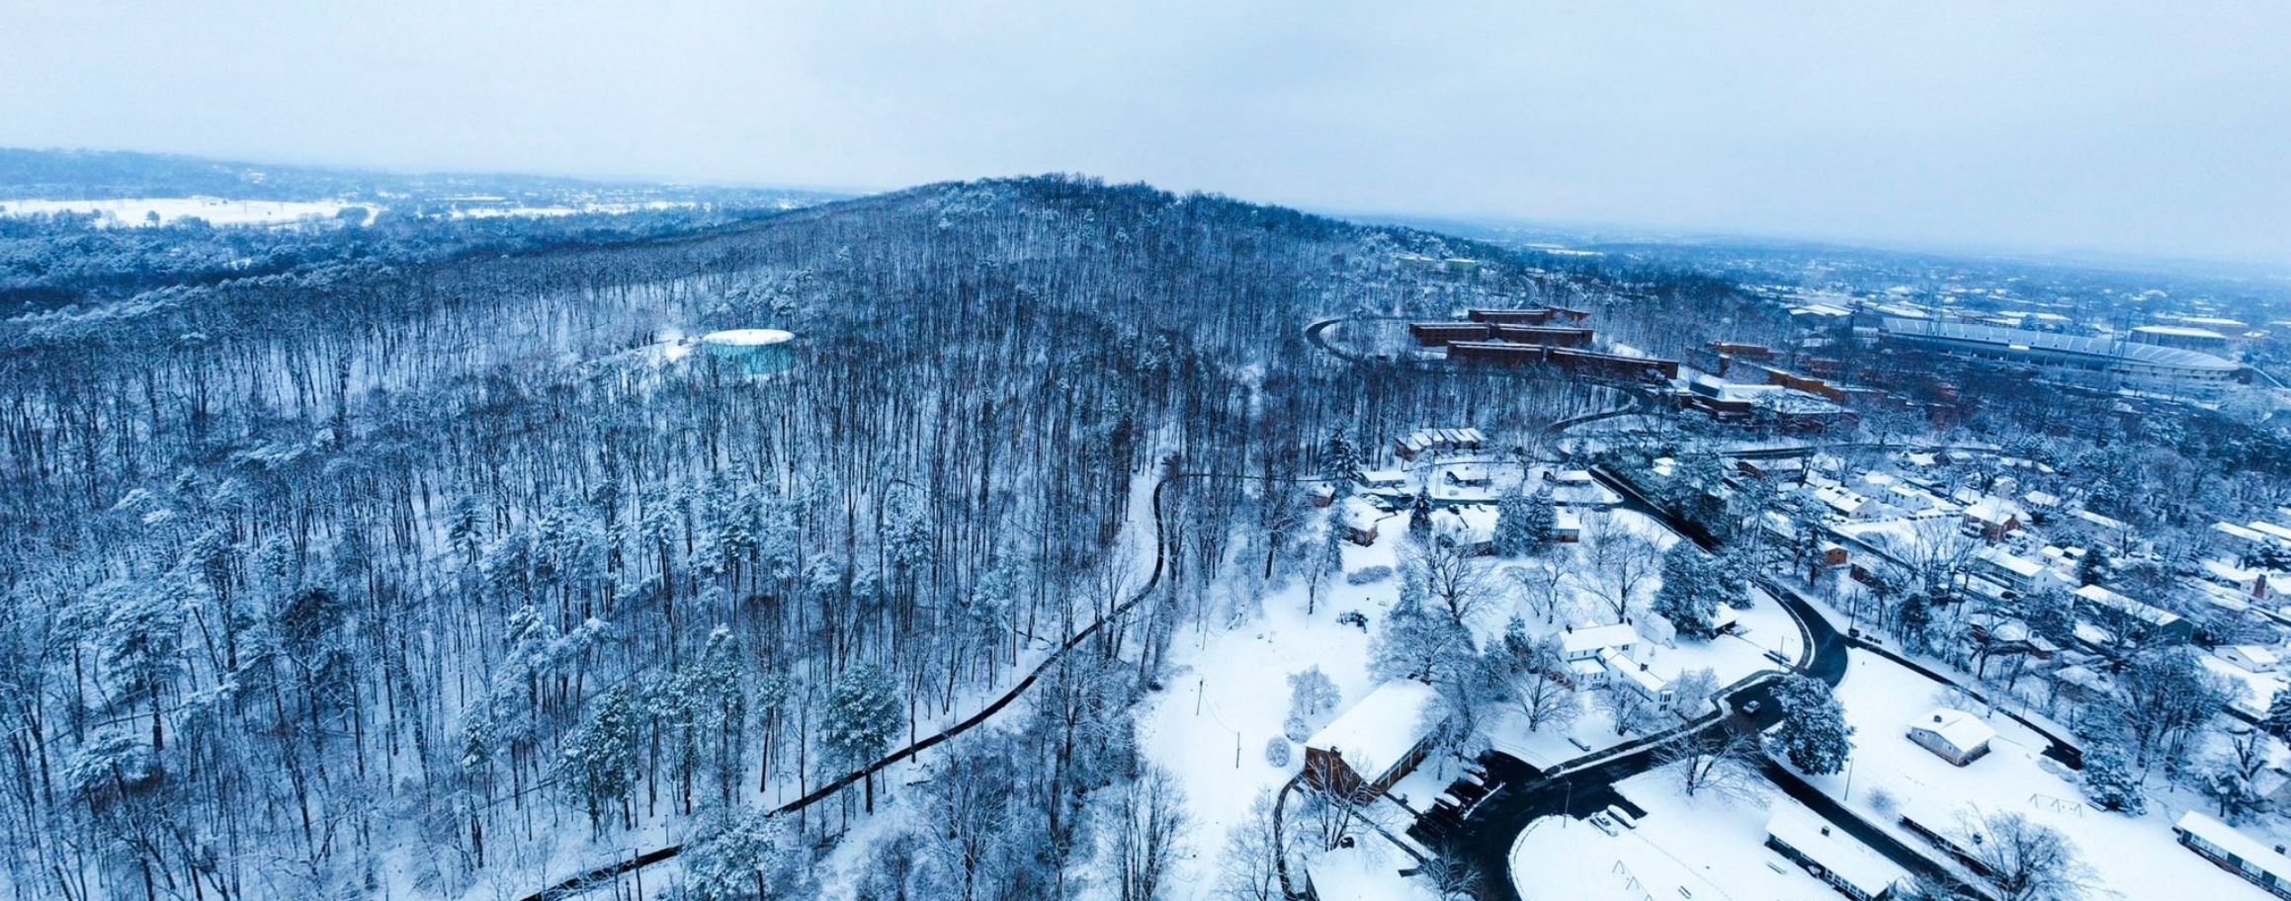

It’s a little known fact that Observatory Hill played a central role in the establishment of Jefferson’s university. In the first century of the university’s existence, the hill (literally) helped to build and sustain the Academical Village. Later, it supported science and medical research, teaching and recreation. Through lectures, hikes, and studying the university’s oldest maps, we’ll discuss the hill’s forest and geo-physical ecology, learn about its cultural history of uses (often conflicting, sometimes shocking), and reveal its under-acknowledged role in UVA’s story.

**OBJECTIVES**

--Discover the history of the hill as a cultural landscape. What is a natural versus constructed environment?

--Develop habits of observing carefully places around you and critiquing the environments around you.

--Consider maps—what is their content and purpose?

--Just enjoy being outdoors and learn about the place you live!

**WALKS AND TOURS**

|  |  |  |
| --- | --- | --- |
| 1 | Sept 6 | INTRO. TOUR: the Academical Village |
| 2 | Sept 13 | WALK: up to O Hill to Jefferson’s spring |
| 3 | Sept 20 | WALK: Historic UVA maps in UVA Library Special Collections |
| 4 | Sept 27 | WALK 2: Exploring the geology of O Hill (guest: Aaron Cross) |
| 5 | Oct 4 | WALK 3: Exploring the forest vegetation on the Hill |
| 6 | Oct 11 | WALK 4: Birding on O Hill |
| 7 | Oct 18 | TOUR: Modern water: Observatory Water Treatment Plant |
| 8 | Oct 25 | WALK: 20th century Cold War science on the Hill |
| 9 | Nov 1 | WALK: Talking trash and waste / UVA Sawmilling project |
| 10 | Nov 8 | TOUR: McCormick Observatory + wrap up |

**WEEKLY ASSIGNMENTS**

Weekly thought reflections on what you saw and learned on our walks. Submissions can be thought essays, photographs, and at least two hand drawn sketches taken from somewhere on the hill.

**RESOURCES**

“Downhill / Uphill: Material Flows Between a Mountain and an Academical Village”by Nancy Takahashi and Garth Anderson. Landscript 5 Journal.

*Infinite Cities: A Trilogy of Atlases* by Rebecca Solnit

Maps viewed in UVA Special Collections Library.

